Announcing!
Fun in the Garden!
At Laura Conyers Smith Rose Garden
In Jacob L. Loose Memorial Park
in Kansas City, Missouri
2019
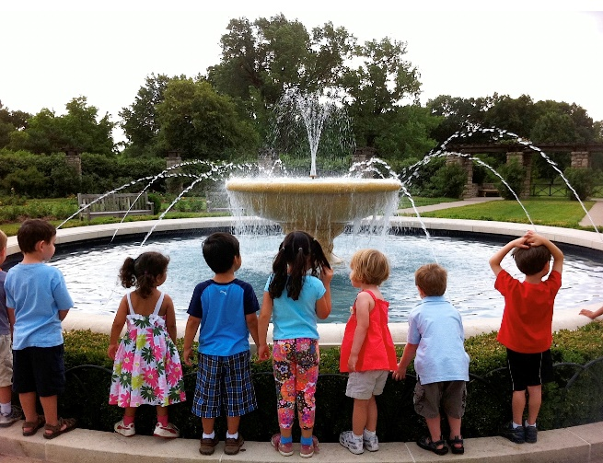

Take a Field Trip to the Laura Conyers Smith Rose Garden at Loose Park! Beginning on May 2, 2019-Sept.27, 2019. The classes are Tuesday, Thursday and Friday for students in grades PK- 5th.
There is no cost!
A great experience for Summer School and Daycare Field Trips!!!
Group Capacity-50 students or less.
The visit to the garden will be done in 3 parts.
Part 1- A short focused lesson on a topic that is age appropriate.
Part 2- Become a scientist and observe and investigate the garden.
Part 3- Debrief and short project to match the lesson.
Lessons for Grade Levels
PK-2 Shapes in the Garden*
K-1- What Plants Need to Grow
K-5- Parts of a Plant *
3-5- Who’s Bugging Your Roses? (insects in the garden) *
* Lessons adjusted for grade level using grade level standards
Dates and Time
The classes at the Rose Garden will be Tuesday, Thursday, and Friday mornings. There are two times available on each day 9:30 AM - 10:30 AM, or 11:30AM - 12:00 PM. The visit is for one hour.
Dress: Play clothes and tennis shoes.
Teachers stay with their class / group. Please have 1 or 2 adult volunteers with your group.
If you are interested in setting up a Field Trip to the Laura Conyers Smith Rose Garden, please complete the attached form and email it to Julie Spaeth at spaethjm@gmail.com.

We hope to see you at the Rose Garden!

Registration for Fun in the Garden at Loose Park
Name of Organization:_______________________________________
Date requested: __________________ Time: ___ 10:00- 11:00
___11:30- 12:30
Contact person for Organization/group
Name __________________________ Phone Number______________

Email address__________________________________________
Grade Level of children:__________ No. of Children_______________
Please check the class you would like your group to participate in:
- PK-1 Shapes in the Garden
- K-1- What Plants Need
- K-5- Parts of a Plant-
- 3-5- Who’s Bugging Your Roses (insects in the garden)
Any important information we need to know about your group or their needs.__________________________________________________________________________________________________________________________________________________________________________________________
Please submit form three weeks before arriving.
Send via U.S. Mail to:
Fun in the Garden Classes
Loose Park Garden Center
5200 Pennsylvania Ave.
Kansas City, MO 64112

Or, E-mail to: spaethjm@gmail.com

