Fun in the Garden 2020!
At Laura Conyers Smith Rose Garden
in Jacob L. Loose Memorial Park
in Kansas City, Missouri 2020
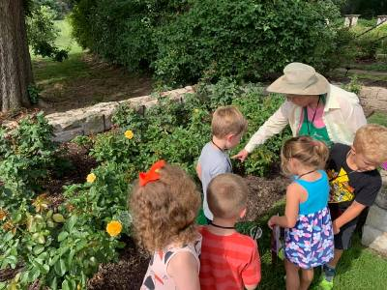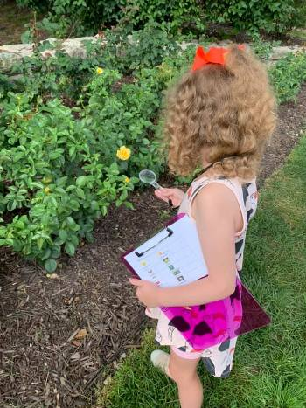

Take a field trip to the Laura Conyers Smith Rose Garden at Loose Park! Field trip classes can be scheduled May 5th- Sept 24th, 2020, for children in PK – 5 Grade. The classes will be on Tuesday, Thursday and Friday at 9:30-10:30 or ll:00- 12:00. The field trip is free and a great experience for your school, summer school and day care field trips.

Group Capacity-50 students or less.
The visit to the garden will be done in three parts.
Part 1- A short, focused lesson on a topic that is age appropriate.
Part 2- Create a project that matches the topic.
Part 3- Become a scientist and observe and investigate the garden. There will be a short debriefing of the observation in the garden before the children leave the garden.
Lessons for Grade Levels
PK-2 Shapes in the Garden *
K-1- What Plants Need to Grow
K-5- Parts of a Plant *
K-5- Who’s Bugging Your Roses? (insects in the garden) *
* Lessons adjusted for grade level using grade level standards
Dates and Time
The classes at the Rose Garden will be Tuesday, Thursday, and Friday mornings. There are two times available on each day 9:30 AM- 10:30 AM or 11:00-12:00 AM. The class lasts one hour.
Dress: Play clothes and tennis shoes.
Teachers stay with their class/group. Please have 1 or 2 other adults volunteers including the teacher with your group.
If you are interested in setting up a Field Trip to the Laura Conyers Smith Rose Garden, please complete the attached form and email it to Julie Spaeth at spaethjm@gmail.com. Three weeks before you wish to come to the garden.
We hope to see you soon for fun in the Rose Garden!
Registration for Fun in the Garden at Loose Park
Name of Organization:_______________________________________
Date requested: __________________ Time: ___ 9:30-10:30
___11:00- 12:00
Contact person for Organization/group
Name __________________________ Phone Number______________

Email address__________________________________________

Grade Level of children:__________ No. of Children_______________
Please check the class you would like your group to participate in:
- PK-1 Shapes in the Garden
- K-1- What Plants Need
- K-5- Parts of a Plant
- 3-5- Who’s Bugging Your Roses (insects in the garden)
Is there any important information we need to know about your group or special accommodations your group needs?
______________________________________________________________________________________________________________________________________________________________________________
Please submit three weeks before arriving.

Send form to: spaethjm@gmail. com

